Lowe Pirella Fronzoni
http://www.ibelieveinadv.com/2009/10/e-n-p-a-spray/

Cam Burgess

Are The Anima l Rights Right?
Cam Burgess is a 15-year-old tenth grade student at Forest Heights Collegiate Institute.
Are The Animal Rights Right?

Cameron Burgess

The rights of animals are grossly lacking details that can stop the unnecessary suffering of the animals. They are subject to life, and they can feel pain and pleasure and therefore should be treated humanely, even when they are hunted, or raised to be eaten. As a higher species we must not cause preventable harm to other beings, with inhumane testing on animals, farming, and hunting. “Animals are living conscious creatures and deserve at least a certain level of decency.” Says Fahad Mirza.

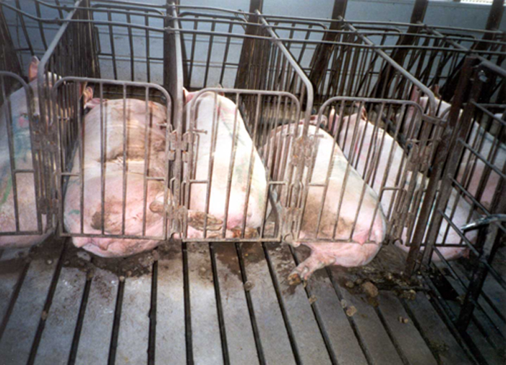
Every year in the Gulf of Saint Lawrence, young seals aged 12 days to 3 months are killed for their fur. This brings up the controversy of farming and hunting animals benevolently. This seal hunt is tradition, and a source of income, but independent veterinarians investigated 76 carcasses, and it was concluded that the methods the seals were killed caused the animals to suffer. Even though hunted and farmed animals are destined to die, they should be treated well while they are alive. The confinement of livestock can be so small; the animal can’t even turn around. This is no way for an animal to live. Animals trapped for fur are trapped in a contraption similar to bear traps, leaving them to starve, freeze, bite their own limb off, or be eaten by a predator. Farmers and hunters should rethink their methods if unnecessary suffering involved.
http://advocacy.britannica.com/blog/advocacy/2010/04/how-farm-animal-reforms-also-benefit-residents/
A living being is not an object. Any inferior species should not be mandated because of their inability to reason. If that were true, infants and humans in a vegetative state would not be our responsibility to care for. All animals can fell happiness and discomfort like a family dog, any harm caused upon them they can feel. All living organisms are needed to sustain ecosystems, and ultimately life on earth, and therefore, should not be treated like an object to abuse.
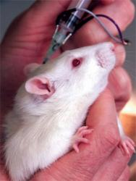
You may think that science depends on testing on animals to analyze drugs, study disease and other scientific purposes, but the reality is tests on animals are unnecessary and inhumane. Diseases and drugs affect certain species differently than others, meaning one organism may not be harmed, and another could die. Animal testing is erratic and consequently perilous. Forty percent of all research funding from the U.S. National Institute of Health goes to animal testing. That forty percent could go into another field where animals are neither tortured nor humiliated. Lastly, there are no boundaries when it comes to animal testing; anything goes. Anything from infecting the being with deathly flesh eating viruses to repeated electrocution.
http://www.aboutmyplanet.com/science-technology/animal-testing/

“I'm proud that Ontario has the strongest Animal Welfare act in Canada. Animals have always been vulnerable to mistreatment from cruel or opportunistic people. They have limited ability to protect themselves, and so they need the protection of compassionate people, and caring laws.” Says Richard Burgess. We do not have to become vegetarians, just strive to make unnecessary suffering of any being, no longer a problem.

